Mujtaba Shahid Faizi
#131818
BSCS-5A
LAB 7 OF OS

TASK 1:
#include <stdio.h>
int main() {
int a[10],b[10],x[10],i,j,smallest,count=0,time,n;
double avg=0,tt=0,end;
printf("enter the number of Processes:\n");
scanf("%d",&n);
printf("enter arrival time\n");
for(i=0;i<n;i++)
scanf("%d",&a[i]);
printf("enter burst time\n");
for(i=0;i<n;i++)
scanf("%d",&b[i]);
for(i=0;i<n;i++)
x[i]=b[i];
b[9]=9999;
for(time=0;count!=n;time++) {
smallest=9;
for(i=0;i<n;i++) {
if(a[i]<=time && b[i]<b[smallest] && b[i]>0 ) smallest=i;
}
b[smallest]--;
if(b[smallest]==0) {
count++;
end=time+1;
avg=avg+end-a[smallest]-x[smallest];
tt= tt+end-a[smallest]; } }
printf("\n\nAverage waiting time = %lf\n",avg/n);
printf("Average Turnaround time = %lf",tt/n);
return 0; }
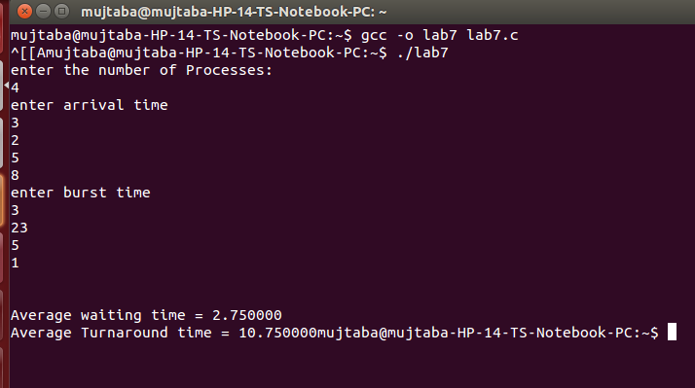

TASK 2:
#include <stdio.h>
int main()
{
int arrivalTime[10], burstTime[10], niceValues[10], i, j, smallest, count = 0, time, n;
double avg = 0, tt = 0, end;
float virtualTime[10];
printf("Enter the number of Processes:\n");
scanf("%d", &n);
printf("Enter arrival time\n");
for (i = 0; i < n; i++) {
printf("Enter arrival time of process %d: ", i + 1);
scanf("%d", &arrivalTime[i]);
}
printf("\n\nEnter burst time\n");
for (i = 0; i < n; i++) {
printf("Enter burst time of process %d: ", i + 1);
scanf("%d", &burstTime[i]);
}

printf("Enter nice values of processes \n Values can be -5,-1,0,1,5\n");
for (i = 0; i < n; i++) {
printf("Enter nice values of process %d:\n ", i + 1);
scanf("%d", &niceValues[i]);
}

for (i = 0; i < n; i++) {
if (niceValues[i] == -5) {
virtualTime[i] = burstTime[i] * 0.3;
}
else if (niceValues[i] == -1) {
virtualTime[i] = burstTime[i] * 0.7;
}
else if (niceValues[i] == 0) {
virtualTime[i] = burstTime[i] * 1;
}
else if (niceValues[i] == 1) {
virtualTime[i] = burstTime[i] * 1.3;
}
else if (niceValues[i] == 5) {
virtualTime[i] = burstTime[i] * 3.1;
}
}

printf("Virtual time for all the processes is:\n");
for(i = 0; i < n; i++) {
printf("Virual time of process %d is: %f\n", i + 1,virtualTime[i]);

}

getchar();
getchar();
return 0;
}
